Installation

Installing Java
The JRE( Java Runtime Environment) is usually already installed on the operating system. But with the JRE one can only run Java programs. To be able to develop programs we need the JDK (Java Development Kit).
The Website http://www.oracle.com/technetwork/java/javase/downloads/ contains the Java downloads. I suggest installing the newest JDK version.
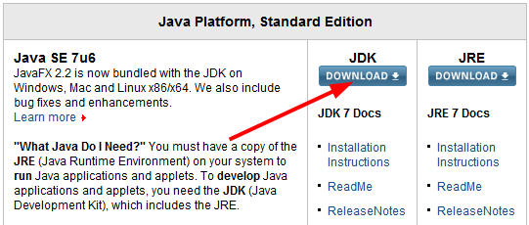
Take not of where the installation directory. We will later need to direct Eclipse to this directory.

Installing Eclipse (incl. e(fx)clipse)
You can also program Java with a simple text editor and the command line. But usually a development environment is used, which is essential for real projects.
We use Eclipse here as it is free and widely used (there are others, of course, such as Netbeans or Intellij IDEA).
Eclipse consists of a core program and countless (!) Plugins that can be installed as needed. We use a preconfigured package with Eclipse and the plugins that we need.
Go to http://efxclipse.org/install.html and download Eclipse 4.2 SDK as a "Preconfigured distro".
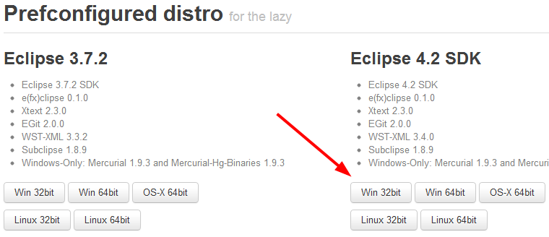

Eclipse Configuration
Start Eclipse. Eclipse prompts you for the location where your projects are stored. This place is called a "workspace". One can easily have multiple workspaces.
Close the "Welcome" screen that appears after the start.
Open the Menu Window | Preferences and go to Java | Installed JREs. Click Add ... and select Standard VM. Then choose under JRE Home the directory where you installed the Java JDK and click Finish. Now select jdk1.7... as default. Delete the JRE that was previously there. Then click OK.

Eclipse Projects
To create a new Eclipse project, select File | New | Java Project.
Importing projects
You will get some preconfigured Eclipse projects containing our exercises. These can be imported as follows: File | Import ... | Existing Projects into Workspace. If it's a zip file, select archive file and choose the file. Now, one or many projects from the zip file should appear below. Select the desired project and press Finish.
Exporting projects
To export an Eclipse project, click with the right mouse button on the project and select Export ... Select Archive File. Then you may specify the export location and file name.

Installing JavaFX Scene Builder
For developing graphical user interfaces we use the JavaFX Scene Builder.
Download the latest JavaFX Scene Builder under http://www.oracle.com/technetwork/java/javafx/downloads/ and install it.

