Nazi Propaganda: Art and Literature

Hitler saw art as an expression of race. In his view the Aryans alone were capable of creating true art, and the 'degenerate art' of the modern period was a sign of racial degeneration. The racial and ideological 'renewal' of the German people on which he and his movement were engaged, the purging of the 'decadent Jewish-Liberal culture' of the Weimar period, would create the conditions for the flourishing of a new German art which would reject the weak and the ugly and glorify the healthy, the strong, and the heroic. Art would no longer be restricted to an arrogant and degenerate elite but would once more be rooted in the people, a true expression of the spirit of the Volk.

1) Adolf Hitler’s speech at the opening of the House of German Art in Munich (19 July 1937)
[...] Ability is the necessary qualification if an artist wishes his work to be exhibited here. People have attempted to recommend modern art by saying that it is the expression of a new age; but art does not create a new age, it is the general life of peoples which fashions itself anew and often looks for a new expression [...]. A new epoch is not created by litterateurs but by the fighters, those who really fashion and lead people, and thus make history [...]. It is either impudent effrontery or an almost inconceivable stupidity to exhibit to people of today works which perhaps ten or twenty thousand years ago might have been made by a man of the Stone Age. They talk of primitive art, but they forget that it is not the function of art to retreat backwards from the development of a people: its sole function must be to symbolize that living development.
The new age of today is at work on a new human type. Men and women are to be healthier and stronger. There is a new feeling of life, a new joy in life. Never was humanity in its external appearance and in its frame of mind nearer to the ancient world than it is today [...]. This, my good prehistoric art stutterers, is the type of the new age, but what do you manufacture? Misformed cripples and cretins, women who inspire only disgust, men who are more like wild beasts, children who, were they alive, must be regarded as under God's curse. And let no one tell me that that is how these artists see things. From the pictures sent in for exhibition it is clear that the eye of some men portrays things otherwise than as they are, that there really are men who on principle feel meadows to be blue, the heaven green, clouds sulphur-yellow, or, as perhaps they prefer to say, 'experience' them thus. I need not ask whether they really do see or feel things in this way, but in the name of the German people I have only to prevent these miserable unfortunates, who clearly suffer from defects of vision, attempting with violence to persuade contemporaries by their chatter that these faults of observation are indeed realities or from presenting them as 'art'.
There are only two possibilities here. Either these 'artists' do really see things in this way and believe in what they represent. Then one has only to ask how the defect in vision arose, and if it is hereditary the Minister for the Interior will have to see to it that so ghastly a defect of vision shall not be allowed to perpetuate itself. Or if they do not believe in the reality of such impressions but seek on other grounds to burden the nation with this humbug, then it is a matter for a criminal court. There is no place for such works in this building. The industry of architects and workmen has not been employed to house canvases daubed over in five hours, the patients being assured that the boldness of the pricing could not fail to produce its effect, that the canvas would be hailed as the most brilliant lightning creation of a genius. No, they can be left to cackle over each other's eggs!
The artist does not create for the artist. He creates for the people [Volk], and we will see to it that the people in future will be called in to judge his art. No one must say that the people has no understanding for a really valuable enrichment of its cultural life. Before the critics did justice to the genius of a Richard Wagner, he had the people on his side, whereas the people has had nothing to do with so-called 'modern art'. The people has regarded this art as the outcome of an impudent and shameless arrogance or of a simply deplorable lack of skill. It has felt that this art stammer, these achievements which might have been produced by untalented children of eight to ten years old, could never be considered an expression of our own times or of the German future. […] an art which cannot count on the readiest and most intimate agreement of the great mass of the people, an art which must rely upon the support of small cliques, is intolerable. Such an art only tries to confuse, instead of gladly reinforcing, the sure and healthy instinct of a people. The artist cannot stand aloof from his people. […]

2) Museum guides
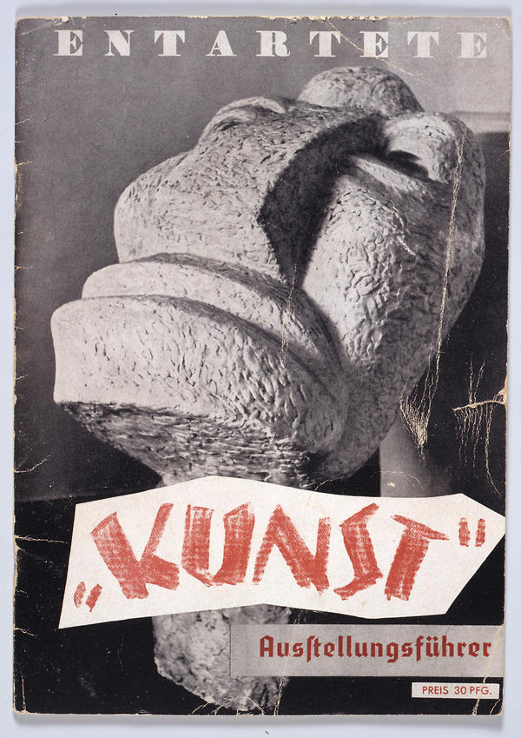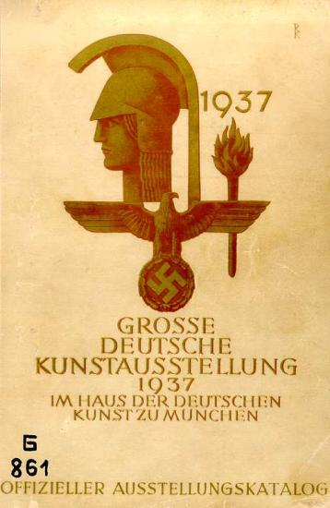

3) Louis P. Lochner’s account of a book burning (10 May 1933)
The whole civilized world was shocked when on the evening of 10 May 1933 the books of authors displeasing to the Nazis, including even those of our own Helen Keller, were solemnly burned on the immense Franz Josef Platz between the University of Berlin and the State Opera on Unter den Linden. I was a witness to the scene.
All afternoon Nazi raiding parties had gone into public and private libraries, throwing on to the streets such books as Dr Goebbels in his supreme wisdom had decided were unfit for Nazi Germany. From the streets Nazi columns of beer-hall fighters had picked up these discarded volumes and taken them to the square above referred to.
Here the heap grew higher and higher, and every few minutes another howling mob arrived, adding more books to the impressive pyre. Then, as night fell, students from the university, mobilized by the little doctor, performed veritable Indian dances and incantations as the flames began to soar skyward. When the orgy was at its height, a cavalcade of cars drove into sight. It was the Propaganda Minister himself, accompanied by his bodyguard and a number of fellow torchbearers of the new Nazi Kultur. 'Fellow students, German men and women!' he cried as he stepped before a microphone for all Germany to hear him. 'The age of extreme Jewish intellectualism has now ended, and the success of the German revolution has again given the right of way to the German spirit [...]. You are doing the right thing in committing the evil spirit of the past to the flames at this late hour of the night. It is a strong, great and symbolic act, an act that is to bear witness before all the world to the fact that the spiritual foundation of the November Republic has disappeared. From these ashes there will arise the phoenix of a new spirit[...]. The past is lying in flames. The future will rise from the flames within our own hearts […].... Brightened by these flames our vow shall be: The Reich and the Nation and our Führer Adolf Hitler: Heil! Heil! Heil!

4) Regulation of the Chamber of Literature (25 April 1935)
§1. The Reich Chamber of Literature maintains a list of such books and writings which threaten the National Socialist cultural aspirations. The circulation of these books and writings by libraries to which the public have access and by the book trade in any form (publishers, bookshops, mail order, door to door sales, lending libraries etc.) is forbidden […].
§3. Anyone who contravenes the regulations of §1 & 2 [...] must, therefore, expect his exclusion from the Reich Chamber of Literature [...].
§4. Requests for inclusion in the lists of §§1 & 2 are to be directed to the Reich Chamber of Literature. The decision concerning such requests will be taken by the President of the Reich Chamber of Literature in consultation with the Reich Minister of Popular Enlightenment and Propaganda.

5) List of banned books (31 December 1938)
1. German-language Marxist literature of all categories (27%). 2. All literature directed against National Socialism and the Third Reich from abroad (11%). 3. German-language literature of foreign powers dealing with questions which in the Nazi view affected Germany's vital interests. 4. Literature from the Christian camp directed against the NS ideology and the ambitions of the totalitarian State. 5. The literature of the 'House of Ludendorff (a cranky religious cult). 6. All literature of a pacifist-liberal tendency. 7. German-language literature in which the 'basic values' of the NS ideology were 'undermined' and 'falsified'. 8. Literature which contained criticism of legislative measures of the NS Government (e.g. Sterilization Law). 9. Literature of the 'traitors' round Ernst Rohm (former Chief of Staff of the SA) and Otto Strasser (pre-1933 Nazi rebel). 10. 'Nationalist-reactionary literature' (e.g. monarchist). 11. Literature which was inopportune for foreign policy reasons. 12. Literature which could be to the detriment of the military security and defence of Germany. 13. Literature which appeared liable to weaken racial strength (e.g. encouraging birth control). 14. The 'corrupting asphalt literature of the literati of a decadent civilization'. 15. Pornographic literature. 16. Quack and occult literature. 17. Kitsch and literature exploiting National Socialism for commercial advantage. 18. Jewish works of all kinds. Before the war, however, no book was put on the index purely on the grounds that the author was Jewish, although Jewish origin provided a powerful argument in addition to others.

6) Hans Hinkel, the General Secretary of the Reich Chamber of Culture, on the state of German theatre (January 1945)
Even on the stages of numerous major theatres or even state theatres nowadays there is a surfeit of 'Blood and Soil', a Party art form which is necessarily bad and must be rejected in the interests of the high demands of artistic achievement. Quite apart from the fact that the characters in such super-Nordic plays and the actors portraying them must be rejected by anyone of sound instinct, no matter how National Socialist they put themselves over as! It does not matter whether we are dealing with the now famous Herr Hintertupfer or another new virtuoso. One day they will all crumble through their own dishonesty and their so-called coordination and will have to let more honest and more able artists take over. The results of this so-called purging of the stage must be rejected even by the most avid Party supporter.
Attempts were made to encourage new talent with competitions, exhibitions, subsidized instruction and so on. Simultaneously, efforts were made to bring art to the people, with an emphasis on the statistics of those attending the events regarded as more important than the quality of what was being produced. Nothing could disguise or change the all-pervading atmosphere of cultural mediocrity.

texts: J. Noakes and G. Pridham (eds). Nazism 1919-1945. Volume 2: State, Economy and Society 1933-1939. Exeter 1995. (adapted)
images: http://www.dhm.de/lemo/objekte/pict/643_1/index.html http://www.dhm.de/lemo/objekte/pict/g861/index.html

