The Hiroshima disaster - a doctor's account

Marcel Junod was the first foreign doctor to reach Hiroshima after the atom bomb attack on 6 August 1945. Junod, the new head of the ICRC's delegation in Japan, arrived in Tokyo on 9 August 1945 - the very day that the United States dropped a second atomic bomb, this time on Nagasaki. Junod, who had been travelling for two months and had not caught up with the news, was astounded:
“For the first time I heard the name of Hiroshima, the words "atom bomb". Some said that there were possibly 100,000 dead; others retorted 50,000. The bomb was said to have been dropped by parachute, the victims had been burnt to death by rays, etc...”
Information was hard to come by, and Junod's immediate task was to visit Allied prisoners of war held in Japan (Emperor Hirohito's surrender broadcast came on 15 August). It was only after one of the ICRC delegates in the field sent Junod a telegram with apocalyptic details of the Hiroshima disaster that Junod could set the wheels in motion for a belated, but still vital, relief effort. On 8 September he flew from Tokyo with members of an American technical commission, and a consignment of relief provided by the US armed forces.
“At twelve o'clock, we flew over Hiroshima. We... witnessed a site totally unlike anything we had ever seen before. The centre of the city was a sort of white patch, flattened and smooth like the palm of a hand. Nothing remained. The slightest trace of houses seemed to have disappeared. The white patch was about two kilometres in diameter. Around its edge was a red belt, marking the area where houses had burned, extending quite a long way further, difficult to judge from the airplane, covering almost all the rest of the city. It was an awesome sight...”
Hiroshima was a major regional centre, with a port, industries and a military garrison, with a population totalling some 400,000. Before the fateful 6 August, it had been virtually free of air raids. The day after their arrival, Junod and the American group set out to find out more about the effects of the bomb.
“The first signs of these effects were visible four miles or so from the bomb's dropping point. The roofs looked denuded, as their tiles had been blown off by the blast. In places, the grass was bleached, as if dried; the Japanese journalist explained to me that the plants, vegetables and rice up to five or six miles from the bomb's epicentre had lost their green colour immediately after the explosion. They only got their colour back three or four weeks later. However, some plants, obviously more sensitive, had died.
At three miles from the bomb's epicentre, some houses had been flattened like cardboard. The roofs were completely caved in; the rafters stuck out all round. This was the familiar sight of cities destroyed by explosive bombs. At two and a half miles, there were only piles of beams and planks, but the stone houses seemed intact. At just over two miles from the town centre, all houses had been gutted by fire. All that remained was the outline of their foundations and heaps of rusty metal. This area looked like the towns of Tokyo, Osaka and Kobe, destroyed by incendiary bombs. At one mile or so everything had been torn apart, blasted and swept away as if by a supernatural power; houses and trees had disappeared.”
Junod's priority, once in the city proper, was to check on the situation in the hospitals, many of them makeshift places.
“This emergency hospital is in a half-demolished school. There are many holes in the roof. On that day, it was pouring with rain and water was dripping into the patients' rooms. Those who had the strength to move huddled in sheltered corners, while the others lay on some kind of pallets; these were the dying. There are eighty-four sick and injured in this hospital with ten nurses and twenty schoolgirls, who seem to be very little girls, aged from 12 to 15 years, to look after them. There is no water, no sanitary installations, no kitchen.
A doctor comes in from outside to visit the sick every day. The medical care is rudimentary; dressings are made of coarse cloth. A few jars of medicine are lying around on a shelf. The injured often have uncovered wounds and thousands of flies settle on them and buzz around. Everything is incredibly filthy. Several patients are suffering from the delayed effects of radioactivity with multiple haemorrhages. They need small blood transfusions at regular intervals; but there are no donors, no doctors to determine the compatibility of the blood groups; consequently, there is no treatment.”
Things were better at the Red Cross hospital, which had withstood much of the blast and fire damage:
“All the laboratory equipment had been put out of action. Part of the roof had caved in and the hospital was open to the wind and the rain. One of the Japanese doctors told me that a thousand patients had been taken in on the day of the disaster: six hundred had died almost immediately and had been buried elsewhere, in the immediate vicinity of the hospital. At present, only two hundred remained. There were no blood transfusions because there was no equipment to carry out examinations and the donors had either died or disappeared.”
As Junod moved around the blighted city, he pieced together what had happened from various first-hand accounts:
“At about 8.15 a.m., when the inhabitants were going to work, a sudden blinding light, pink and white, appeared in the sky; this was accompanied by a sort of shudder, followed almost immediately by suffocating heat and a blast-wave sweeping away everything in its path. When we visited the ruined station in Hiroshima, the hands of the clock had stopped at this historic moment, 8.15. … ...In a few seconds […] thousands of human beings in the streets and gardens in the town centre, struck by a wave of intense heat, died like flies. Others lay writhing like worms, atrociously burned. All private houses, warehouses, etc, disappeared as if swept away by a supernatural power. Trams were picked up and hurled yards away, as if they were weightless; trains were flung off the rails.”
Junod noted the consequences of the bomb for Hiroshima's medical corps: out of 300 doctors, 270 died or were injured; out of 1,780 nurses, 1,654 perished or were injured. He ended his journal with an appeal for the bomb to be banned outright, just as poison gas was outlawed in the aftermath of the First World War.

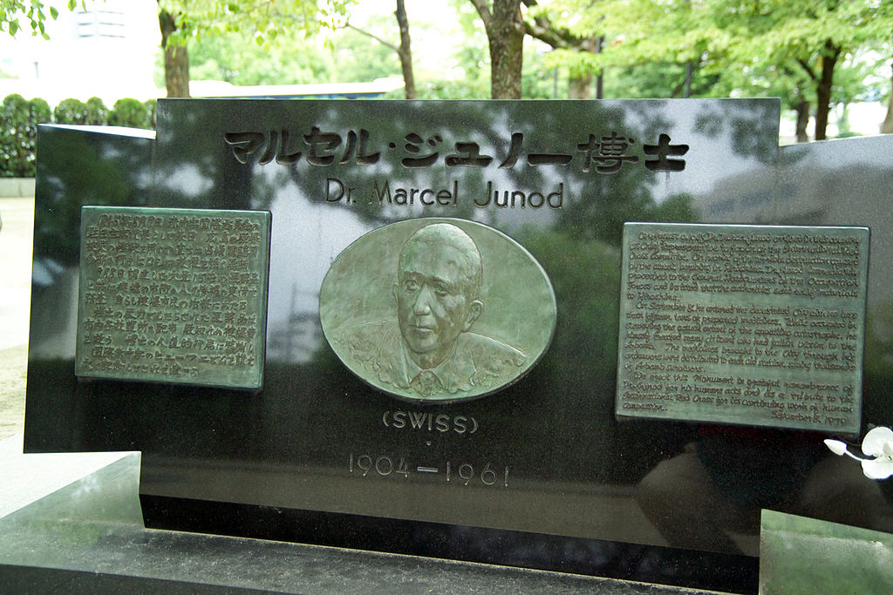
The text of the inscription is:
On August 9, 1945 Dr. Marcel Junod arrived in this country as Chief Representative to Japan of the International Red Cross Committee. On hearing of the terrible destruction caused by the atomic bombing in Hiroshima, Dr. Junod immediately proceeded to the General Headquarters of the Occupation Forces and insisted that the authorities send relief materials to Hiroshima. On September 8, he entered the devastated city with no less than fifteen tons of prepared medicines. While occupied in surveying the actual extent of the appalling catastrophe, he himself treated many citizens who had fallen victim to the A-bomb. The medicines brought to the city through his endeavours were distributed to each aid station, saving thousands of A-bomb survivors.
We erect this Monument in grateful remembrance of Dr. Junod for his humane acts and as a tribute to the International Red Cross for its continuing work of human compassion. September 8, 1979.

http://www.icrc.org/eng/resources/documents/misc/hiroshima-junod-120905.htm (adapted)

