**Chemistry Lab Course**

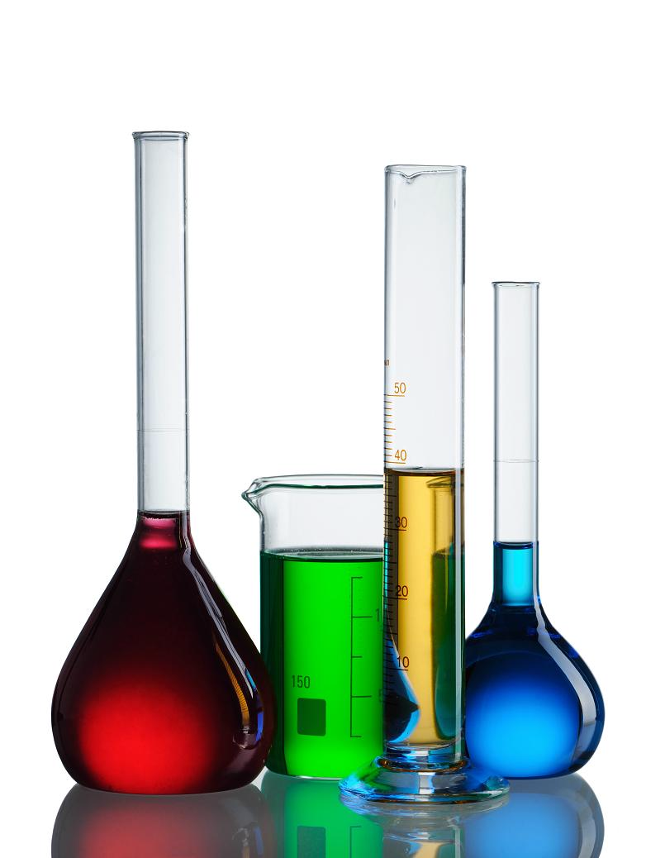

**Kantonsschule Zürich Nord**

**Tilmann Geldbach 2015/2016**

**Preface**

The aim of this lab course is that you learn how to conduct simple chemical experiments and how to document these experiments. You should learn to carefully observe and – based on these observations – come up with explanations and hypotheses about what you have seen.

During the course you will learn basic lab techniques, the proper use of standard equipment as well as how to handle harmful chemicals.

**Organisation**

It is expected that you have studied the lab instructions of the current experiment **before** the lesson has started. Remaining questions can be clarified before the lab session starts.

* In most cases you will be working in pairs. You should always take notes on what you are doing and on what can be observed.
* There is a work sheet for most of the experiments. You should return this work sheet at the end of the lab session or **unasked** in the next theory lesson at the latest.
* These work sheets will be graded with bonus points.
* The lab should be fun! Therefore make an effort to create an atmosphere that is pleasant both to you and your classmates. You should help each other both during the experiments and during clean-up.
* Not all substances that are used in the lab are harmless. Pay attention to the safety instructions below and on the sheets of the respective experiment.

**Safety**

There are essentially three ways in which a chemical substance may enter your body: by oral uptake, by inhalation or by absorption through the skin. One further differentiates between an acute or chronic exposition. The former leads to an immediate response while the reaction to the latter is only visible after a longer period often due to a frequent exposition to a harmful substance.

**Safety Regulations**

* It is mandatory to wear safety goggles during experiments. You may only take them off if explicitly stated or when leaving the room.
* It is strictly forbidden to eat and drink in the lab (this also includes chewing gum).
* Avoid any contact with the reagents used and regularly wash your hands. Gloves should only be used when handling particularly caustic or toxic chemicals.
* The opening of a test tube or other vessel should never point towards another person or yourself – especially when the content in the vessel is heated.
* Working with open flames, reduced or elevated pressure requires additional attention. Never leave your experimental set-up unattended.
* Spilled substances have to be removed immediately. Especially the area around the balances has to be kept spotless!
* If desired you may wear a lab coat.
* Long hair has to be tied together (pony tail or the like).
* Please inform your teacher if you injure yourself even if the incident seems harmless.
* Be aware of the potential hazards and act accordingly. A mindless attitude in the lab endangers you and your classmates and is not tolerated.

# Hazard Symbols

|  |  |
| --- | --- |
|  | **Explosive** Explosionsgefährlich (E)  Schlag, Stoss, Reibung, Funkenbildung und Hitzeeinwirkung vermeiden. |
|  | **Flammable**  Entzündlich (F+)  Kontakt mit Zündquellen/Gefahrenquellen (Luft, Wasser) vermeiden. |
|  | **Oxidizer** Brandfördernd (O)  Jeden Kontakt mit brennbaren Stoffen vermeiden. |
|  | **Poison**  Giftig  Jeglichen Kontakt mit dem menschlichen Körper vermeiden und bei Unwohlsein sofort den Arzt aufsuchen. |
|  | **Severe chronic hazard** Gesundheitsschädlich (Xn)  Kontakt mit dem menschlichen Körper, auch Einatmen der Dämpfe, vermeiden und bei Unwohlsein den Arzt aufsuchen. |
|  | **Low level hazard** Reizend (Xi)  Dämpfe nicht einatmen und Berührung mit Haut und Augen vermeiden. |
|  | **Corrosive** Ätzend (C)  Dämpfe nicht einatmen und Berührung mit Haut, Augen und Kleidung vermeiden. |
|  | **Environmental hazard** Umweltgefährlich (N)  Je nach Gefährdungspotential nicht in Kanalisation, Boden oder Umwelt gelangen lassen. |

**Environmental Aspects**

Working with chemicals may pose a serious threat both to health and the environment. Stick to the following rules and guidelines:

* Do not use excessive quantities of a chemical without an obvious need.
* Close the bottles of a reagent immediately (particularly solvent bottles) to both avoid contamination as well as evaporation.
* Make yourself familiar with the potential hazards of the substances used during a lab exercise
* Solutions containing heavy metals or organic solvents (with the exception of ethanol and acetone in small quantities) most not be poured down the drain but are collected in designated waste containers.
* There are instructions as to how chemicals need to be disposed of at the end of each experiment sheet – these have to be obeyed!

# Important Apparatus and Glass Ware

The terminology of the equipment shown below should be known.

|  |  |  |  |
| --- | --- | --- | --- |
| **beaker**  Becherglas | **Erlenmeyer flask**  Erlenmeyerkolben | **narrow-necked bottle**  Enghalsflasche | **wash bottle**  Spritzflasche |
| **roundbottom flask**  Rundkolben | **suction bottle**  Saugflasche | **suction (Büchner) filter**  Nutsche (Büchnerfilter) | **funnel** **with fluted filter**  Trichter mit Faltenfilter |
| **dropping funnel**  Tropftrichter | **measuring cylinder**  Messzylinder | **measuring pipette**  Messpipette | **transfer pipette**  Vollpipette |
| **Peleus ball**  Peleusball | **raising platform**  Hebebühne | **magnetic stirrer**  Magnetrührer | **measuring flask**  Masskolben |

# Some Basic Operations in a Chemistry Lab

**How to Use the Bunsen Burner**

**Lighting the Bunsen burner**

1. The first step is to **check for safety** - long hair tied back, safety glasses on, books and papers away from the flame, apparatus set up not too close to the edge of the table... 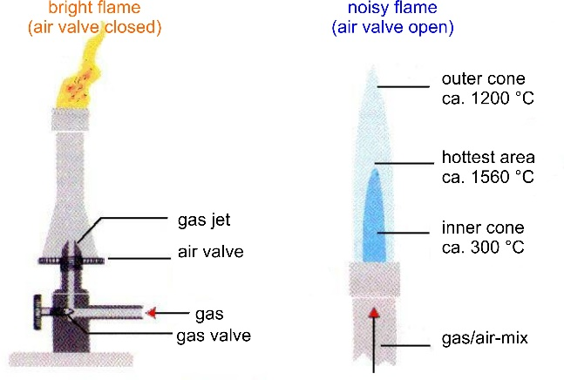
2. Check that valvesare closed then open the main gas valve (yellow tab). To open it, you must first push the tap down before doing a 90° turn
3. Light a match and hold it close to the top of the burner
4. Open the gas valve on the Bunsen burner – you should see a bright yellow flame
5. Open the air supply valve – the colour of the flame changes to blue, the temperature rises to above 1000 °C

**Turning off the Bunsen burner**

1. Close the main gas supply
2. Once the flame is extinguished close the gas and air supply valve

**Volumetric Transfer**

**Always make sure that the equipment used to aspirate from stock solutions and reagent flasks is absolutely clean and avoid any cross-contamination.**

**How to Use a Pipette Filler (Peleusball)**

The three-valve design allows you to release air, draw liquid into the pipette, and accurately release liquid.

1. Insert the top of the pipette into the bottom of the pipette filler.
2. Release air from the pipette filler by squeezing valve “A” on the top of the pipette filler while simultaneously squeezing the bulb. The amount of air you release is dependent on the size of the pipette you are using—release more air for larger volume pipettes.
3. Insert the tip of the pipette into the liquid to be dispensed.
4. Siphon liquid into the pipette to the desired level by squeezing valve “S” on the bottom of the pipette filler. This uses the vacuum created in the bulb to draw liquid into the pipette. Be careful not to draw liquid into the pipette filler.
5. Empty the pipette by squeezing valve “E” on the side-tube. This allows you to release liquid at the desired rate and to the desired level.
6. It works best to fill the pipette past the zero mark on step 4 (valve “S”) and then draw the level down to the zero mark on step 6 (valve “E”). Once the pipette is filled to the level desired the contents can be dispensed using valve “E”.

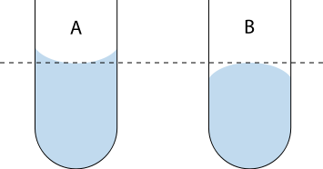When reading a depth scale on the side of an instrument filled with liquid, such as a pipette, the **meniscus** must be taken into account in order to obtain an accurate measurement. Depth must be measured with the meniscus at eye level and at the centre of the meniscus, i.e. the top of a convex meniscus or the bottom of a concave meniscus.

A bit of liquid will always remain in the tip of a pipette and the scale is calibrated accordingly. To properly empty a pipette its tip should touch the wall of the vessel.

**Gravimetric Transfer**

**Always make sure that the equipment used to remove substances from a reagent flask is absolutely clean! Avoid any cross-contamination and keep the balances clean!**

Gravimetric transfers have the advantage that the measured quantity is not temperature-dependent. Usually one performs a tare (balance set to zero) before weighing substance into a reception vessel

* Normally different reception vessels ought to be used for each substance
* If possible choose the sequence of addition in such a way that the solid can be washed into the reaction vessel with some solvent – this is particularly important if the solid shows electrostatic properties
* Choose the balance in accordance with the required precision
* Do not use hot glassware on a balance as this will give rise to imprecise measurements

**Quantitative Transfer**

Quantitative Transfer simply means that *all* the material to be transferred from one place to another must make the trip. For example, every particle of solid must be transferred from the weighing paper to the (clean) beaker. This can be done by carefully tipping the creased weighing paper to allow the solid to fall into the beaker. Tapping the paper with a spatula will knock particles into the beaker. Finally, the paper should be rinsed into the beaker, to remove all traces of the solid.

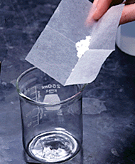 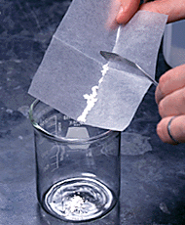 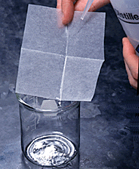

If you are transferring a solution or heterogeneous mixture to another vessel, rinse the container with solvent to be sure the transfer is quantitative. The rinsings should be transferred to the second vessel along with the rest of the mixture or solution.

# Vacuum Filtration

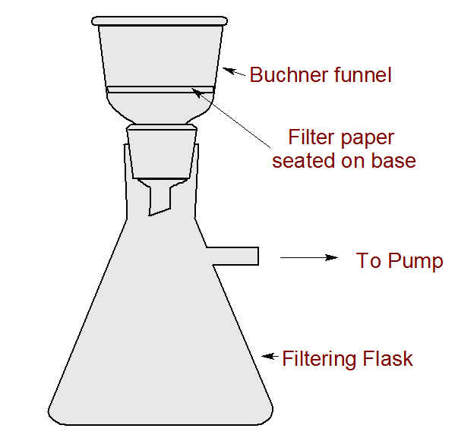Filtrationis commonly the operation which is used for the separation of solids from fluids (liquids or gases) by interposing a medium through which only the fluid can pass. The fluid that passes through is called the **filtrate** or **mother liquor**; the solid that remains in the filter is the **residue**.

In vacuum filtration the mixture of solid and liquid is poured through a filter paper in a Büchner funnel. The solid is trapped by the filter and the liquid is drawn through the funnel into the flask below, by a vacuum.

To prepare for a vacuum filtration, gather together a filter flask, Büchner funnel, tubing, filter paper, clean solvent, disposable dropper, and your sample. Turn on the vacuum using the knob on the outside of the hood. Check the vacuum by feeling for suction at the end of your tubing. The vacuum should be strong enough to hold the tubing to your finger without falling off. Connect the tubing to the side arm of your filter flask and check the suction at the top of the flask (left). Place the black rubber ring adapter in the top of the flask and then the Büchner funnel. Check again for good suction by placing your gloved hand across the top of the funnel. If you do not feel strong suction, there is a poor connection and a leak somewhere in your system.

Prepare to filter your sample by placing a filter paper in the Buchner funnel and wetting it with clean solvent. You should see the paper being sucked down against the holes in the funnel and the solvent should quickly pass through into the filter flask.

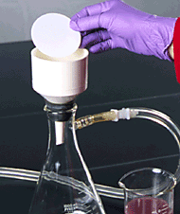 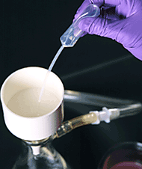 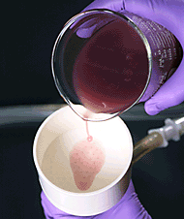 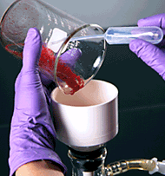

To filter your sample, slowly pour into the centre of the filter paper. Rinse the solid on the filter paper with more clean solvent (only if the solid is really poorly soluble in the solvent you are using). Continue to draw air through the solid, to evaporate any remaining solvent in your sample. When you are finished, first break the vacuum at the connection between the flask and the trap, only then turn off the vacuum.

http://www.dartmouth.edu/~chemlab/resources/dot_clear.gif

# Practising Basic Lab Operations

Lab

The following tasks do not need to be done in the order in which they are described below (otherwise long queues at the balance result). Any of these operations will be needed in the labs that will follow thus it is important that you are familiar and feel comfortable with these procedures.

# Aims & Relevance

* Getting familiar with basic lab equipment and procedures

**Evaporating Solvent in a Test Tube**

* Determine the weight of an empty large test tube
* Aspirate exactly 2.5 mL brine (sodium chloride solution) into the test tube and heat the solution using the Bunsen burner until all solvent has been removed.
* Determine the amount of sodium chloride that is left in the test tube
* Calculate the concentration [mol/L] of the brine solution

**CAUTION: Never point the opening of the test tube towards yourself or another person!**

**Filtration**

* Using approximately 25 mL of the available suspension isolate the solid via vacuum filtration.
* Wash the solid with water and check whether the filtrate is clear.

**Preparation of a Stock Solution**

Document your calculations and whether you encountered any problems.

* Prepare a 250 mL solution of potassium permanganate K[MnO4] with a concentration of 0.005 mol/L.
* Dilute this solution by a factor of 10 by aspirating 10 mL of this solution (use a transfer pipette) into a 100 mL measuring flask and add fill it with distilled water up to the 100 mL mark.
* Bring this solution forward to have its concentration measured. You have to document how you proceeded. In doing so state precisely:
  + which equipment was used (hint: use equipment that allows for as precise a measurement as possible)
  + how you proceeded (step-by-step instructions)
  + which substances in which quantities were used
  + which problems were encountered

**Reaction Rates**

**Lab**

# Aim & Relevance

* Determination of the effect of concentration and temperature on the reaction rates

**Theory**

Addition of oxonium ions (H3O+) to a solution containing thiosulphate ions (S2O32-) triggers a two-step reaction which ultimately yields sulphur (S8).

1st step: S2O32- (aq) + 2 H3O+ (aq)  H2S2O3 (aq) + 2 H2O (l)

2nd step: 8 H2S2O3 (aq)  8 H2O (l) + 8 SO2 (g) + S8 (s)

As sulphur is insoluble in water a fine yellow precipitate forms with time. You are to measures the time [t] it takes until a sufficient amount of sulphur has formed to make the mixture turbid. By assuming that this amount corresponds to the arbitrary amount “1000 units” of sulphur, one can compare the effect of concentration and temperature.

ATTENTION:

* HCl (aq) and Na2S2O3 (aq) must not come inadvertently into contact – that also applies to the usage of pipettes and stopcocks.
* Test tubes need to be cleaned thoroughly before they are re-used.
* Always the same person has to establish whether the mixture is turbid or not.

**Investigation of the concentration-dependence (experiments A - F)**

By carrying out experiments A to F you will examine how the reaction rate depends on the concentration of thiosulphate ions. This dependence ought to be visualized in a graph (see Exercise 1).

In a large test tube various amounts of thiosulphate solution are filled - as listed in the table – and diluted with water so that a total volume of 10 mL solution results.

|  |  |  |  |  |  |  |
| --- | --- | --- | --- | --- | --- | --- |
|  | **A** | **B** | **C** | **D** | **E** | **F** |
| Volume S2O32- stock solution | 10 mL | 8 mL | 6 mL | 4 mL | 2 mL | 1 mL |
| Volume distilled water | - | 2 mL | 4 mL | 6 mL | 8 mL | 9 mL |

A second test tube is filled with 5 mL hydrochloric acid. Quickly add the acid to the thiosulphate solution and shake the resulting mixture briefly to ensure a homogeneous mixture. The moment the acid is added the stop watch is started in order to measure the time until the mixture is notably turbid.

The concentration of S2O32--ions in the reaction mixture can be calculated by taking the concentration of the S2O32- stock solution (c = 0.1 mol/L) into account. In this particular case the reaction rate is the arbitrary amount “1000 units” sulphur divided by the time measured.

|  |  |  |  |  |  |  |
| --- | --- | --- | --- | --- | --- | --- |
|  | **A** | **B** | **C** | **D** | **E** | **F** |
| Concentration S2O32-  [mol/L] |  |  |  |  |  |  |
| Time until turbid [s] |  |  |  |  |  |  |
| Reaction rate [1000 ES/s] |  |  |  |  |  |  |

**Investigation of the temperature-dependence (experiments R - V)**

**Lab**

By carrying out experiments R to V you will examine how the reaction rate depends on the temperature (while concentrations remain unchanged). This dependence ought to be visualized in a graph (see Exercise 3). According to the Q10 temperature coefficient (RGT-Regel), an increase in temperature by 10 °C ought to cause an increase in reaction rate by a factor of 2-3. Is this also the case for this reaction?

A large test tube is filled with 5 mL thiosulphate stock solution and diluted with 5 mL distilled water. A second test tube is filled with 5 mL of hydrochloric acid. Both solutions are placed in one of the five tempered baths and kept there for at least 10 minutes. Once the solutions have reached the respective temperature the acid is added to the thiosulphate solution as in the previous experiments and the time measured as before. There is no need to keep the mixture in the water bath after the addition.

Note the effective temperature as indicated by the thermometer and not what is stated on the label of the water bath!

|  |  |  |  |  |  |
| --- | --- | --- | --- | --- | --- |
|  | **R** | **S** | **T** | **U** | **V** |
| Concentration S2O32- [mol/L] |  |  |  |  |  |
| Temperature [°C] |  |  |  |  |  |
| Time [s] |  |  |  |  |  |
| Reaction rate [1000 ES/s] |  |  |  |  |  |

# Safety Hazards

|  |  |
| --- | --- |
|  | Hydrochloric acid is caustic – avoid any contact with your skin and eyes. In case of contact rinse with plenty of water. |

## Disposal

All solutions from these experiments can be poured down the drain with plenty of water.

**Distillation of a Binary Mixture**

**Lab**

# Aim & Relevance

* Basic knowledge of the method of distillation as a means to separate mixtures
* Handling of a distillation apparatus
* Data analysis using LoggerPro / Excel

# Theory

Above absolute zero temperature any particle of a substance is in motion and this motion increases with increasing temperature. However, the degree of motion does not depend on the temperature alone but also on the properties of the particle in question. Particularly **intermolecular forces** play an important role. The temperature at which the movement of the particles is high enough to overcome these intermolecular forces is the boiling point (remember: in the gaseous state there are no attractive forces between the particles). The lower the intermolecular forces in a substance are the lower is its boiling point.

In a closed system there is a temperature dependent state above the surface of a liquid: As many particles evaporate from the liquid as particles re-condense. The higher the temperature the more particles are affected within a given period of time and the higher is the **vapour pressure** – that is the pressure caused by those particles which are in the gaseous state.

In principle one can distinguish two different states:

* A liquid is **evaporating** if the vapour pressure of the liquid is lower than the overall pressure. The energy required to evaporate particles is taken from the environment – the temperature of the liquid decreases.
* A liquid is **boiling** if the vapour pressure of the liquid is equal to the overall pressure. The energy required has to be supplied by an additional energy source.

Heating an (ideal) mixture of two volatile substances A and B (with A having the higher volatility, or lower boiling point) until the mixture is boiling results in a vapour above the liquid which contains a mixture of A and B. The ratio between A and B in the vapour will be different from the ratio in the liquid: the ratio in the liquid will be determined by how the original mixture was prepared, while the ratio in the vapour will be enriched in the more volatile compound, A. The vapour goes through the condenser and is removed from the system. This in turn means that the ratio of compounds in the remaining liquid is now different from the initial ratio (i.e., more enriched in B than the starting liquid).

The result is that the ratio in the liquid mixture is changing, becoming richer in component B. This causes the boiling point of the mixture to rise, which in turn results in a rise in the temperature in the vapour, which results in a changing ratio of A : B in the gas phase (as distillation continues, there is an increasing proportion of B in the gas phase). This results in a slowly changing ratio A : B in the distillate.

If the difference in vapour pressure between the two components A and B is large (generally expressed as the difference in boiling points), the mixture in the beginning of the distillation is highly enriched in component A, and when component A has distilled off, the boiling liquid is enriched in component B.

**Data Collection and Analysis using Logger-Pro**

**Lab**

The change in temperature during distillation is recorded using the LoggerPro software. Adjust the settings in the “Data Collection“ tab as follows:

**Mode:** Time Based

**Length:** 120 min

**Sampling Rate**: 20 samples/min

# 

# Data Analysis using Excel

The recorded data is saved as .csv file (tab „File“ → „Export As“ → „CSV“) and the generated file opened in Excel

* In the tab „Daten“ select the entry „Externe Daten“ and next the option „Textdatei importieren“
* Select the respective .csv-file and click on „Importieren“
* Select „Weiter“ in the window that has just opened and select „Komma“ as separator; all data should now be visible in three separate columns.
* Generate a graph for the temperature curves (X,Y scatter) and format the graph

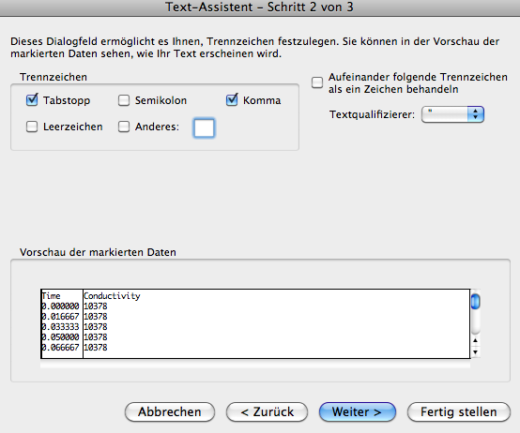 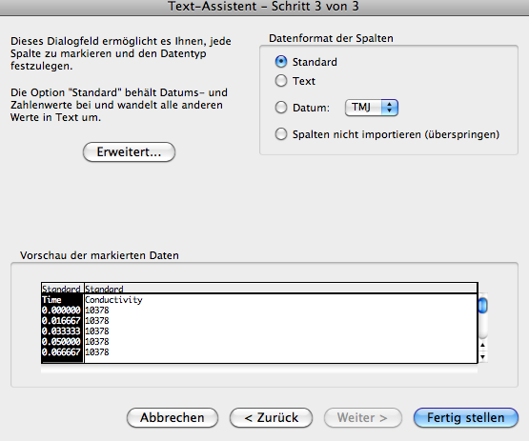

# Experimental

**Lab**

Follow the procedure described below and stick to the sequence. **Wear safety goggles throughout the experiment! Never leave a distillation process unattended!**

* Start heating the oil bath to approximately 90 °C (heater setting on level 3). Note: Normally one would start heating only after the apparatus was completely assembled but due to time constraints this is not possible.
* Label 9 test tubes with numbers from 1 to 9. These will be used to collect 5 mL fractions of the distillate.
* Add 50 mL of the solvent mixture together with two or three boiling stones to the round bottom flask.
* Assemble the distillation apparatus and connect the temperature probes to the Vernier interface and turn on the cooling water (a weak but continuous flow of water is sufficient).
* Lower the apparatus into the oil-bath so that the liquid in the round bottom flask is approximately half immersed into the oil bath. **Start the stop watch and the data collection with LoggerPro!**
* Adjust the heating in such a way that about one to two drops are collected per second. If the distillation proceeds too quickly the apparatus ought to be lifted a bit from the oil bath. If the distillation proceeds too slowly the apparatus ought to be immersed a bit deeper into the oil bath.
* Once a volume of 5 mL is collected (that corresponds to the lower section of the test tube holder) a new fraction has to be started by collecting into a new test tube. Note time and temperature in the respective table (see below) when a new fraction is started.
* The distillation can be stopped when only 3-4 mL of liquid remain in the distillation flask. It is well possible that the liquid only suffices for eight rather than nine fractions.
* Switch off the heating and lift the apparatus out of the oil bath. Also turn off the cooling water. Once the apparatus has sufficiently cooled down it can be dismantled. Wipe off any residual oil at the outside of the distillation flask using some tissues or paper towels. Any liquid remaining in the distillation flask is collected in a designated waste battle (including boiling stones).

# Analysis of Distillation Fractions

The composition of the collected fractions is determined as follows:

* Add approximately 5 mL of water to each test tube (to top bar of the test tube holder) then close the test tube with a rubber stopper and shake the content vigorously.
* After shaking wait until two phases are visible. The lower phase is a mixture of substance B and water, the upper phase is substance A. Fractions collected at the end of the distillation will only show one phase.
* Aspirate the **upper** phase using a suitable measuring pipette and determine the volume of compound A, then eject the aspirated liquid back into the test tube.
* Calculate the amount of substance A in each of the nine fractions in % (an aspirated volume of 5 mL corresponds to 100 %). Draw a graph showing the amount of substance A relative to the fraction number.
* Add to your Excel graph the times during which the respective fractions were collected and whether there is any correlation between the composition of the fractions and the temperature at the head of the distillation bridge.

# Safety Hazards

|  |  |
| --- | --- |
|  | Propanol and hexane are highly flammable, hexane is hazardous – avoid contact with your skin and do not inhale any hexane vapours. |

# Disposal

All liquids are collected in a designated waste bottle – no solvent may be poured down the sink!

**Recrystallisation as a Means of Purification**

**Lab**

# Aim & Relevance

* Purification of a salt that is contaminated with other solid substances
* Handling of vacuum filtration equipment
* General knowledge of solubility

# Theory

The most common method of purifying solid compounds is by recrystallization. In this technique, an impure solid compound is dissolved in a solvent and then allowed to slowly crystallize out as the solution cools. As the compound crystallizes from the solution, the molecules of the other compounds dissolved in solution are excluded from the growing crystal lattice, giving a pure solid.

Crystallization of a solid is not the same as precipitation of a solid. In crystallization, there is a slow, selective formation of the crystal framework resulting in a pure compound. In precipitation, there is a rapid formation of a solid from a solution that usually produces an amorphous solid containing many trapped impurities within the solid's crystal framework. For this reason, experimental procedures that produce a solid product by precipitation always include a final recrystallization step to give the pure compound.

The process of recrystallization relies on the property that for most compounds, as the temperature of a solvent increases, the solubility of the compound in that solvent also increases. For example, much more table sugar can be dissolved in very hot water (just below the boiling point) than in water at room temperature. What will happen if a concentrated solution of hot water and sugar is allowed to cool to room temperature? As the temperature of the solution decreases, the solubility of the sugar in the water also decreases, and the sugar molecules will begin to crystallize out of the solution (this is how rock candy is made).

**The steps in the recrystallization of a compound are**

1. Find a suitable solvent for the recrystallization
2. Completely dissolve the impure solid in a **minimum** volume of **hot** solvent
3. Remove any insoluble impurities by filtration of the hot solution
4. **Slowly** cool the hot solution to crystallize the desired compound from the solution
5. Filter the mixture to isolate the purified solid compound

The following graph depicts the solubility/saturation curves of the salts potassium permanganate (KMnO4) and potassium perchlorate (KClO4). 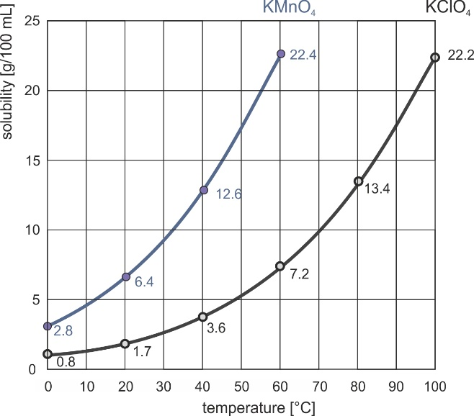

* If the concentration in the solution corresponds to a point below the curve an **unsaturated** solution is present. It is possible to dissolve more substance until the curve is reached
* If the point is on the curve a **saturated** solution is present
* Above the curve the system is described as being **oversaturated**. In most cases as much solid will precipitate from the solution until the curve is reached.

If, for example, one considers the solubility of these two salts at 40 °C one notices that it is possible to dissolve 12.6 g of KMnO4 per 100 mL of water, but only 3.6 g of KClO4.

After the crystallisation at low temperature it is important not to heat up the mixture during filtration. Therefore the filtration ought to be done swiftly which is achieved by performing the filtration under vacuum. In doing so, take care that the holes of the Büchner funnel are entirely covered by the filter paper. It is recommended to wet the filter paper with solvent then turn on the vacuum and to only add the slurry once the filter paper is sucked tightly against the funnel. Mix the slurry prior to pouring it into the funnel to make sure that as little solid as possible remains in the Erlenmeyer flask.

**Lab**

# Experimental

Attention: Remember to collect a small sample of the crystallised solid after each recrystallisation cycle in order to protocol your progress.

1. Approximately 8 g crude potassium perchlorate and 40 mL distilled water are heated in an Erlenmeyer flask using the Bunsen burner until the water gently boils. Once all potassium perchlorate has dissolved (it may be necessary to add some more water) the hot mixture is filtered into another Erlenmeyer flask.

Next the Erlenmeyer flask is placed in an ice bath. As the solution cools down a larger quantity of crystalline potassium chlorate forms. Once the mixture has cooled to approximately 10 °C the solid is separated via vacuum filtration from the violet solution.

1. The solid is collected from the funnel placed into a clean Erlenmeyer flask and a smaller quantity of water than was used before added (25 – 30 mL). As before the flask is heated using the Bunsen burner until the water gently boils. If necessary add more water to the mixture but avoid any excess water as this would lead to loss of potassium perchlorate. Once a clear solution is obtained the cooling/filtration cycle is repeated.

To obtain as much clean potassium perchlorate as possible the following points ought to be considered:

* + At room temperature only add a small amount of water to the solid – a clear solution ought to be present only at high temperature.
  + Take care to cool the mixture to a low temperature and maintain this low temperature for a while – crystallisation requires some time.
  + When doing the vacuum filtration be as quantitative as possible – as little solid as possible ought to remain in the flask or funnel. Do not use additional water to wash away solid from the flask.

1. Repeat the above described sequence two to four more times (until a white solid is obtained) each time using less water (as inevitably some product gets lost)
2. Finally determine the weight of the damp white solid.

# Assessment Criteria

You will receive bonus points for the colour and the amount of potassium perchlorate remaining at the end of the lab exercise.

# Safety Hazards

|  |  |
| --- | --- |
|  | Potassium perchlorate and potassium permanganate are oxidisers and may react with flammable substances. Avoid contact with your skin and thoroughly wash your hands in case of contact. |

# Disposal

The solid and liquid residues are collected in two designated flasks.

**Chromatography of Essential Oils**

**Lab**

# Aim & Relevance

* General knowledge of the technique of thin layer chromatography
* Analysis of essential oils regarding their composition

**Theory**

Chromatography is the collective term for a set of laboratory techniques for the separation of mixtures. The mixture is dissolved in a fluid called the **mobile phase***,* which carries it through a structure holding another material called the **stationary phase**. The various constituents of the mixture travel at different speeds, causing them to separate. The separation is based on differential partitioning between the mobile and stationary phases. Subtle differences in a compound's partition coefficient result in differential retention on the stationary phase.

Thin layer chromatography involves as stationary phase a thin layer of adsorbent like silica gel, alumina or cellulose. As the mobile phase rises through the layer of adsorbent, it meets the sample mixture, which starts to travel up the stationary phase with the solvent. If the adsorbent is made of a polar material non-polar substances travel farther as they are retained less. The following graphic shows exemplarily the separation of a mixture.

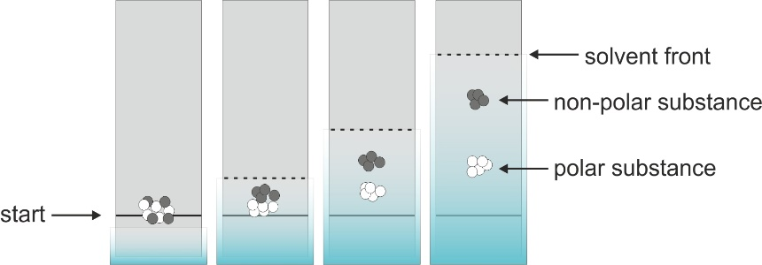

The ratio of the distance travelled by a substance spot to the distance travelled by the solvent front, measured from the starting line is referred to as **retardation** or **retention factor Rf**.Accordingly, the retention factor has values between 0 and 1.

|  |  |
| --- | --- |
|  | a = distance travelled by the substance  b = distance travelled by the solvent |

The Rf-value is measured from the centre of the respective substance spot. The Rf-value is specific to any pure substance and can be used to identify a substance. However, the Rf-value depends on a number of factors such as temperature, solvent, adsorbent and can only be reproduced if the measuring conditions are absolutely identical.

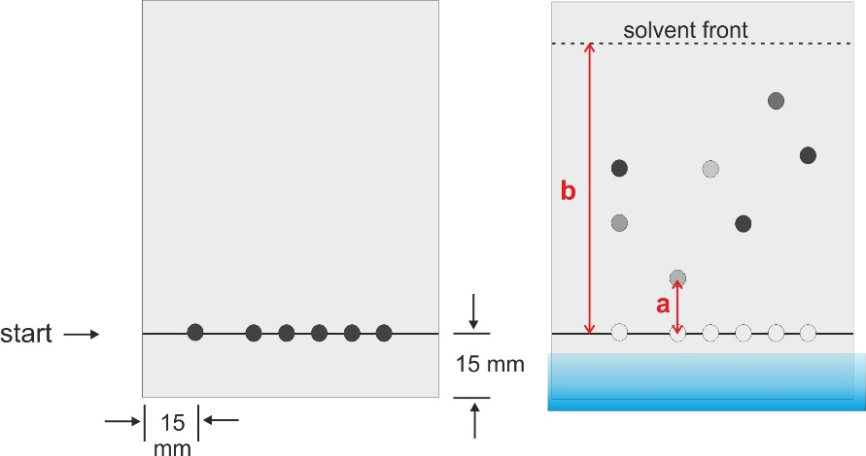

As chemical substances often are colourless it may be necessary to develop a thin layer chromatogram in order to render the spots visible. In the case of fluorescent substances, UV-light may be used to detect the spots. Alternatively, certain chemical substances may be used to colourise those spots.

**Examination of Essential Oils**

**Lab**

The term essential oil refers to substances which are obtained via distillation or extraction from plants and spices. These oils are commonly soluble in solvents such as ethanol or hexane and only poorly soluble in water. Essential oils are mixtures which are often composed of one predominating substance. For example peppermint oil contains up to 40 % menthol.

In this lab course typical herbal plants such as peppermint, thyme and rosemary are analysed regarding their content of the pure substances eucalyptol, thymol, and menthol.



**Procedure**

## Sample Application

Handle the thin layer plate carefully and only hold it at the edges (do not scratch the white surface)

1. Using a soft pen draw a starting line approximately 15 mm from the bottom edge of the plate
2. Make marks for eight starting points as shown below. Take care that you keep a distance of roughly 15 mm from the left and right edges.

The spots must not be too close to the edge as the solvent travels slightly faster at the borders compared to the centre of the plate.

1. Apply approximately 5 micro litres each of the reference substances (thymol, menthol and eucalyptol) on the left side of the plate. Apply approximately 5 micro litres of the essential oils on the right side of the plate. To make a spot on the plate it is important that the capillary is perpendicular to the plate and that you don't apply any pressure as otherwise the stationary phase is damaged. The aim is to make a spot with small diameter. Therefore, as soon as any liquid is absorbed one should remove the capillary and repeat the procedure 3 - 4 times at the same position until the desired amount of liquid has been absorbed.
2. The size and intensity of the spot can be controlled by examining the plate under UV light.

## Separation & Development

Solvent vapours are hazardous – always close the chromatography chamber once the liquid phase is inside. From the moment that the thin layer plate is inside the chamber it mustn't be moved any more.

1. In a small beaker prepare a mixture of exactly 10 mL petrol ether and 2 mL ethyl acetate (Essigester) – this is your mobile phase for the first experiment.
2. Pour the mobile phase into the chromatography chamber and place the thin layer plate inside. The starting line has to be above the level of the solvent. Take care that the white surface doesn't touch the walls of the chamber.
3. Leave the plate inside the closed chamber until the mobile phase has travelled almost to the top of the plate (1 – 2 cm from the edge). If that is the case you can remove the plate from the chamber. Immediately mark the solvent front using a pen.
4. Remove any remaining solvent using a hair dryer and give the plate to your teacher who will apply a chemical in order to render the spots visible. The spots will appear once the plate is heated with a heat gun. Don't heat the plate for too long as this may cause unwanted processes.
5. Write your names on the plate – your teacher will make colour copies which you may need in order to analyse your results.
6. Determine the Rf-values of the reference substances and make assumptions which of these compounds can be found in the natural oils.

**Variation of the composition of the mobile phase**

Prepare a second thin layer plate which only has spots of the three reference substances eucalyptol, menthol and thymol. As mobile phase prepare in a small beaker a mixture of 9 mL petrol ether and 3 mL ethyl acetate. As you only have three spots you should use a small plate for this experiment.

**Variation of the amount of substance**

Select an essential oil of your choice and apply three spots with varying quantity. The first spot should be made with approximately 5 µL, the second with 10 µL and the third with 15 µL of liquid. This plate ought to be developed together with the plate from the above experiment. Apart from the different solvent composition the procedure is exactly as described previously.

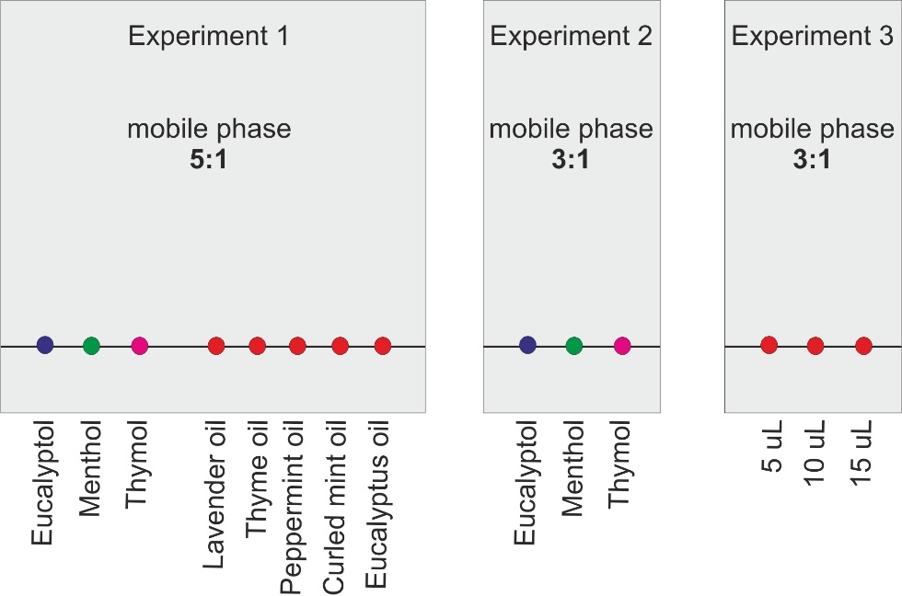

# Safety Hazards

|  |  |
| --- | --- |
|  | Petrol ether and ethyl acetate are highly flammable – do not operate with open flames in the vicinity of those substances. The vapours of these solvents are hazardous. |

# Disposal

The used solvent from the chromatography chamber is collected in a designated bottle. The used thin layer plates and capillaries are collected in a plastic beaker.

**HCl-Fountain**

**Lab**

# Aim & Relevance

* Handling of an apparatus for gas formation
* Synthesis of hydrogen chloride
* Properties of hydrogen chloride and hydrochloric acid

# Theory

Hydrogen chloride (HCl) can be synthesised in the lab from the reaction between sulphuric acid (H2SO4) and sodium chloride (NaCl). The formed gas can be collected with sodium sulphate remaining in the reaction vessel. This is an acid-base reaction in which the very strong acid H2SO4 donates an H+-Ion to the weak base Cl-.

The gastric juice of humans and many animals contains hydrochloric acid with a concentration of 0.1 – 0.5 %. The acid supports various enzymes in breaking down proteins and higher sugar molecules. Dysfunction in the production of gastric juice may be felt as heartburn (Sodbrennen) as hydrochloric acid is corrosive and can affect the tissue of the stomach. Inhaling gaseous HCl may cause pneumonia (Lungenentzündung) as hydrochloric acid is formed within the lungs. Hydrochloric acid is a very strong acid which forms stable salts (chlorides) with many reactants. Hydrogen chloride can be detected via reaction with gaseous ammonia leading to the formation of solid ammonium chloride.

# Experimental

## Detection of HCl

Hydrogen chloride HCl (g) is liberated from concentrated hydrochloric acid. Bring an open bottle of concentrated hydrochloric acid close to an open bottle of concentrated ammonia. The white smoke is due to the formation of ammonium chloride.

## Synthesis of Hydrogen Chloride

1. Assemble the apparatus as shown in the graphic below. Take care that valves at the tubes are open
2. 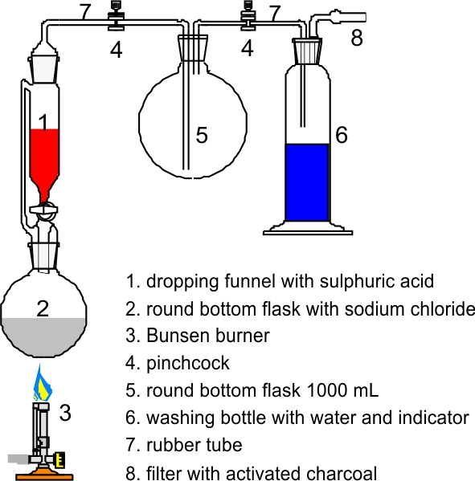Fill the wash bottle (6) half with water and add a few drops of aqueous ammonia and bromothymole blue (the solution should be markedly blue)
3. Place approximately 10 g of sodium chloride (NaCl) into the round-bottom flask (2). Fill 25 mL of concentrated sulphuric acid (highly caustic!) into the dropping funnel (1).
4. **Dropwise** add the sulphuric acid to the sodium chloride. What can be observed?
5. Once all sulphuric acid has been added gently heat the round-bottom flask (2) with the Bunsen burner. Take care that the foam doesn't rise more than a few centimetres.
6. Remove the Bunsen burner and wait until the formation of gas has almost come to an end
7. Close both valves (4) and **immediately** detach the tubing from the dropping funnel. Place the dropping funnel and the round-bottom flask into the hood.

Caution! The formed gaseous hydrogen chloride must not be inhaled – the substance is highly toxic and longer exposure can cause severe damage to your lungs!

## Formation of hydrochloric acid from hydrogen chloride and water

**Lab**

1. Fill the plastic box almost to the brim with water. Colour the water by adding a small quantity of aqueous ammonia and 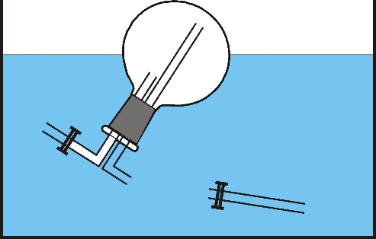bromothymole blue.
2. Immerse the large round-bottom flask upside down into the basin. Below the surface remove the tube with is connected to the **longer** glass tube. The opening of the glass tube must never be above the surface!
3. In case the water does not rise by itself rinse the outside of the round-bottom flask with a little acetone.

# Safety Hazards

|  |  |
| --- | --- |
|  | Concentrated sulphuric acid is extremely caustic and may irreversibly damage your eyes – safety goggles have to be worn at all times. Any contact with skin or clothes has to be washed immediately with lots of water. Gaseous hydrogen chloride is toxic and can cause pneumonia. |

## Disposal

The remaining sodium sulphate and sulphuric acid is rinsed with plenty of water down the drain.

**Cosmetics: Soap, Lotion and a Cooling Gel**

**Lab**

# Aim & Relevance

* Basic knowledge of methods for the formulation of emulsions
* Knowledge of the saponification reaction
* Basic knowledge of surfactants and emulsions

**Theory on Emulsions and Gels**

Main ingredient in lotions are fat or oil and water. These do not form a homogeneous mixture but when stirring vigorously they can form an emulsion. With the aid of emulsifiers (also referred to as surfactants) such emulsions can be stabilised so that the aqueous and the fatty phase do not separate. Molecules that can act as emulsifiers contain both a lipophilic as well as a hydrophilic section enabling such molecules to interact with both polar and non-polar phases.

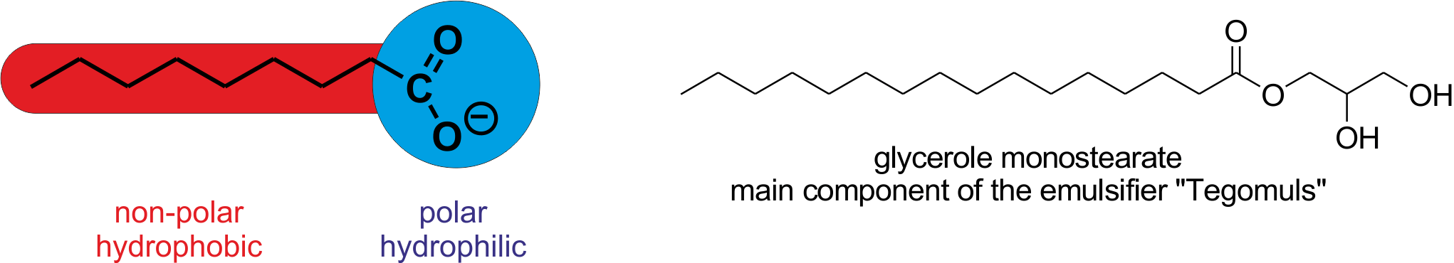

Another method to form stable mixtures of otherwise immiscible substances is via the formation of a gel. A gel consists of a solid three-dimensional network that spans the volume of a liquid medium and ensnares it through surface tension effects. This internal network structure may result from physical or chemical bonds. Virtually any fluid can be used as an extender including water (hydrogels), oil, and air (aerogel).

The technique of mixing various chemical substances to form a new material is called formulation. Although some chemical reactions may take place during a formulation the main focus lies on achieving a certain texture or structure of the mixture. Formulation is of key importance in the pharmaceutical industry as well as in the production of cosmetics, paints and even food.

**Formulation of a Hand Cream**

**Aqueous phase**

* 60 mL of water are heated in a small beaker (~150 mL) to a temperature of 60 - 80° C
* 0.5 g allantonin are dissolved in the hot water and approximately 3 g glycerine added (corresponds to approximately four filled pipettes)

**Fatty phase**

* 5 g tegomuls, ~0.5 g bee wax, ~0.5 g cetanol and 9 g of vegetable oil (select either jojoba oil, coconut oil, almond oil or avocado oil) are mixed together in a medium sized beaker (~400 mL) and heated to 80 °C

**Formulation**

* while stirring constantly the aqueous phase is added to the fatty phase and mixed until the resulting crème is only lukewarm
* Next add half a pipette of potassium sorbate solution (preservative), 5 drops of panthenol solution and 1-2 drops of vitamin E emulsion
* Optionally you may add a few drops of plant extract to adjust the smell of this crème.
* Mix your emulsion once more vigorously and distribute the product into two small jars. In case the crème remains too liquid, apply the electric blender to improve your formulation.

**Formulation of a Cooling Gel**

**Lab**

**Fatty phase**

* 1.5 g menthol are dissolved in a small beaker (~50 mL) in 8 mL viscous paraffin. You may help the dissolution by gently heating the mixture. Attention: The temperature must not exceed 60 °C!

**Aqueous phase**

* 90 mL of water are placed in a medium sized beaker (~500 mL) and are heated to 60 - 80 °C then 15 mL of ethanol are added.

**Formulation**

* While stirring continuously add the fatty phase to the aqueous phase.
* Next add half a pipette of potassium sorbate solution (preservative) and 10 drops of panthenol solution
* While stirring vigorously with the eggbeater 1.5 g gelling agent are added. Take care that there are no lumps in your mixture. While mixing from time to time the gel is allowed to cool to ambient temperature.

The cooled gel is transferred into two aluminium tubed using a spatula and the tube closed with flat pliers.

**Theory on the Saponification Reaction (Esterification)**

Fats are a wide group of compounds whose basis is in long-chain organic acids, called fatty acids. More particularly fats are esters of such organic acids formed with the alcohol glycerol. Glycerol is a triol, meaning that it has three chemically active -OH (hydroxyl) groups. Fats are made when each of these three -OH groups reacts with a fatty acid.



The saponification reverses the formation of a fat from a fatty acid and glycerol by hydrolysing the ester with concentrated sodium hydroxide affording glycerol and the respective carboxylates of the fatty acids. These carboxylates are acting as surfactants explaining why soap is a detergent.

One can distinguish the following types of soap:

* 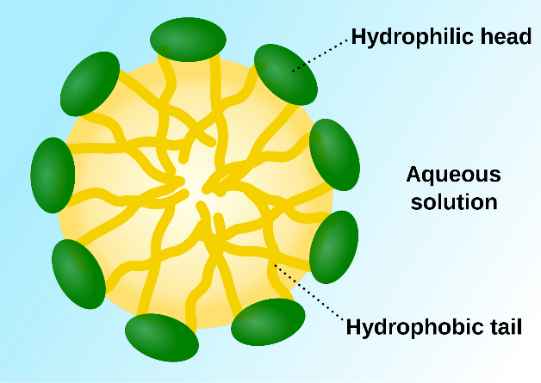**Curd soap** (Kernseife)**:** Made from the sodium salt of the carboxylic acid. Solid at ambient temperature yet soft; well soluble in water.
* **Soft soap** (Schmierseife)**:** Made from the potassium salt of the carboxylic acid. Viscous liquid at ambient temperature; well soluble in water.
* **Lime soap** (Kalkseife)**:** Made from the calcium salt of the carboxylic acid. Solid at ambient temperature; insoluble in water.

The soluble carboxylic acids can form micelles in water: Due to the large Van der Waals force between the non-polar tails of the molecules these align with the polar head facing towards the polar phase.

**Preparation of a simple olive oil soap**

**Lab**

This soap contains an excess of approximately 8% fat and is thus nurturing and gives a fine foam. The quantities listed below allow for the preparation of two small pieces of soap.

Safety goggles have to be worn during the preparation of the soap - sodium hydroxide solution is highly corrosive!

* 49.5 g of olive oil, 18.75 g of coconut fat and 29.25 mL of sodium hydroxide solution (32 w%) are added into a large beaker (~1000 mL).
* The mixture is to approximately 70 °C and stirred from time to time using a wooden spoon. Heating is continued until the mixture has a consistency comparable to pudding (traces of the wooden spoon remain visible for a while).
* The mixture is transferred into two silicon moulds and left for several days to solidify. The saponification reaction continues for some more time gradually decreasing the amount of base within the soap. It is recommended to store the soap for several weeks in a dark and dry place before using. During that time it becomes harder and more yielding when used.

# Safety Hazards

|  |  |
| --- | --- |
|  | Sodium hydroxide solution is highly corrosive – it is imperative to wear safety goggles when working with this substance. If it gets into contact with your skin wash immediately with lots of water. The other substances in this lab exercise are not hazardous. However, be careful while handling the hot solutions. |

**Disposal**

Clean all glassware and other tools with kitchen paper and rinse them with water so that most of your cosmetic products are removed. Put everything back into the boxes.

**Determination of the Hardness of Water**

**Lab**

# Aim & Relevance

* Knowledge of the chemistry related to the hardness of water
* Titration as analytical method

# Theory

Natural water always contains dissolved ions. Common cations are Na+, Ca2+ and Mg2+ ions, common anions include CO32-HCO3- and SO42-. Magnesium and Calcium ions often afford poorly soluble salts which can precipitate. If, for example, Ca2+ and CO32- ions are present in the same solution, CaCO3 precipitates, which eventually may clog pipes or damage electrical appliances. The following equilibrium reaction describes the dissolving and formation of calcium carbonate:

CaCO3(s) + CO2 (aq) + H2O (l)  Ca2+ (aq) + 2HCO3− (aq)

The reaction can go in either direction. Rain containing dissolved carbon dioxide can react with calcium carbonate and carry calcium ions away with it. The calcium carbonate may be re-deposited as calcite as the carbon dioxide is lost to atmosphere, sometimes forming stalactites and stalagmites.

Water containing high concentrations of Mg2+ and Ca2+ ions is referred to as hard water. The hardness of water can, for example, be expressed in French degrees [°fH]. A hardness of 1 °fH is equal to a concentration of 0.1 mmol/L metal ions. Water with a hardness of 0 - 15 °fH is “soft“ water, with 15 - 25 °fH is regarded as “medium hard“ whereas water with values > 25 °fH is considered as “hard“ water.

**Permanent hardness** is hardness (mineral content) that cannot be removed by boiling. When this is the case, it is usually caused by the presence of calcium sulphate and/or magnesium sulphate in the water, which do not precipitate out as the temperature increases. Ions causing permanent hardness of water can be removed using a water softener, or ion exchange column.

**Temporary hardness** is a type of water hardness caused by the presence of dissolved hydrogen carbonate minerals (calcium hydrogen carbonate and magnesium hydrogen carbonate). When dissolved, these minerals yield calcium and magnesium cations (Ca2+, Mg2+) and carbonate and hydrogen carbonate anions (CO32−, HCO3−). The presence of the metal cations makes the water hard. However, unlike the permanent hardness caused by sulphate and chloride compounds, this "temporary" hardness can be reduced by boiling the water. Boiling promotes the formation of carbonate from the bicarbonate and precipitates calcium carbonate out of solution, leaving water that is softer upon cooling.

**Carbonate hardness** is a measure of the alkalinity of water caused by the presence of carbonate and hydrogen carbonate. Mathematically, the carbonate anion concentration is counted twice due to its ability to neutralise two protons, while hydrogen carbonate is counted once as it can neutralise one proton. Carbonate hardness is usually expressed in **degree KH** (**dKH**) (from the German "Karbonathärte"). One degree KH is equal to 17.848 mg/L (ppm) CaCO3. e.g. one degree KH corresponds to the carbonate and bicarbonate ions found in a solution of approximately 17.848 milligrams of calcium carbonate (CaCO3) per litre of water (17.848 ppm). The measurement of KH is usually expressed as mg/L CaCO3 – meaning the concentration of carbonate expressed as if calcium carbonate were the sole source of carbonate ions.

**Calcium hardness** Concentration of dissolved Ca2+ ions

**Magnesium hardness** Concentration of dissolved Mg2+ ions

**Total hardness** Sum of the concentration of dissolved Ca2+ and Mg2+ions

**Titration**, also known as is a common laboratory method of quantitative chemical analysis that is used to determine the unknown concentration of an identified **analyte**. A reagent, called the **titrant** is prepared as a standard solution. A known concentration and volume of titrant reacts with a solution of analyte to determine concentration. The volume of titrant reacted is called titration volume.

The hardness of water can be determined using a suitable **indicator** such as Eriochrome T. Upon reaction with a metal ion such as Ca2+ or Mg2+ this molecule forms a so-called **complex** which causes the indicator to change its colour to purple. If subsequently a reagent such as EDTA is added that interacts more strongly with the metal ions than the indicator the latter will be displaced. As the non-complexed indicator has a different colour the solution will change its appearance once as many EDTA molecules have been added as metal ions are present.

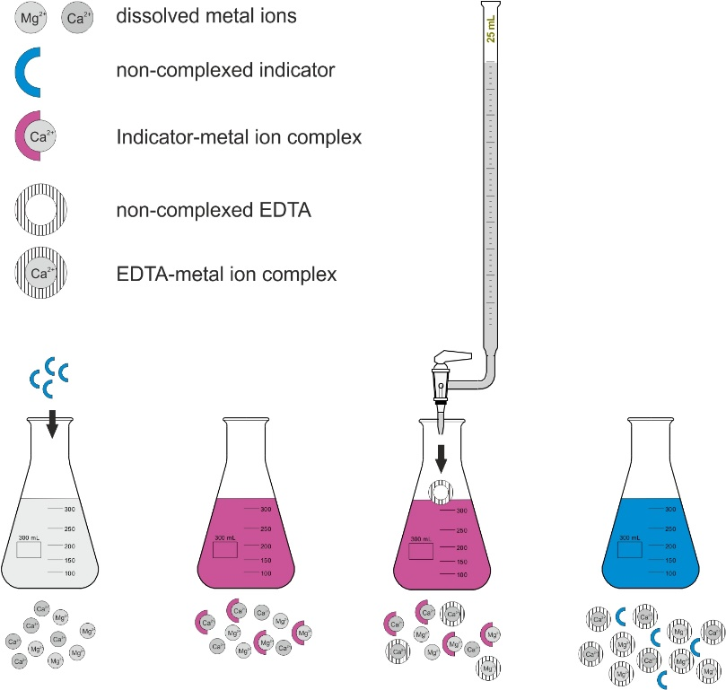

**Lab**

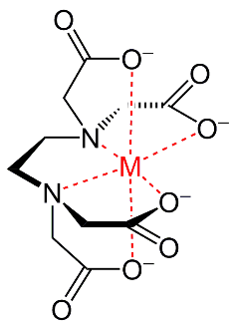The reagent (titrant) used for this purpose is EDTA (also referred to as “Komplexon”) is a molecule that reacts with Ca2+ and Mg2+, respectively, in a ratio of 1:1. In this reaction EDTA acts as a so-called **ligand** that complexes the metal ion.

During the titration experiment the volume of EDTA required to complex all metal ions is determined (change of colour of the indicator). As the concentration of EDTA is known the amount of metal ions present in the sample can be calculated.

EDTA finds widespread use in industry, cosmetics and medicine. It is a common ingredient in washing powder used to mask Ca2+ and Mg2+ ions thereby inhibiting any deposition of poorly soluble calcium and magnesium salts.

**Experimental**

**Determination of the Total Hardness**

* To a water sample of precisely of 100 mL is added 5 mL buffer solution and as much indicator (**Eriochrome T**) that the solution has a distinct red colour.
* The solution is titrated with EDTA solution (c = 0.01 mol/L) until the colour changes from red to blue
* Repeat the entire process with a second sample of 100 mL

**Determination of the Calcium Hardness**

Hydroxide ions react with magnesium ions affording poorly soluble magnesium hydroxide. Accordingly Mg2+ ions are no longer available for a reaction with EDTA – the magnesium ions have been “masked“ with hydroxide ions. Applying this technique it is possible to determine the concentration of calcium ions separately.

* To a water sample of precisely of 100 mL is added 5 mL sodium hydroxide solution (c = 2 mol/L) and as much indicator (**HHSNN**) that the solution has a distinct red colour.
* The solution is titrated with EDTA solution (c = 0.01 mol/L) until the colour changes from red to blue
* Repeat the entire process with a second sample of 100 mL

**Determination of the Carbonate Hardness**

* To a water sample of precisely of 100 mL are added 10 drops indicator (**methyl orange**).
* The solution is titrated with hydrochloric acid (c = 0.1 mol/L) until the first marked change in colour is noticeable. 1 mL hydrochloric acid corresponds to an amount of CO32- of 0.05 mmol.

**Lab**

* Repeat the entire process with a second sample of 100 mL

# Safety Hazards

|  |  |
| --- | --- |
|  | Sodium hydroxide and hydrochloric acid are caustic. Avoid any contact with your skin and wear safety goggles. |

**Disposal**

Any occurring solutions can be poured down the drain.

**Limestone, Carbonic Acid and Lime Plaster**

**Lab**

# Aim & Relevance

* Acid-base reactions involving carbonic acid and hydrogen carbonate
* Knowledge of the inorganic CO2 turnover
* Chemistry of important materials for building

# Theory

Of the carbon stored in the geosphere, about 80% is limestone and its derivatives, which form from the sedimentation of calcium carbonate stored in the shells of marine organisms. The solubility of limestone in water and weak acid solutions leads to karst landscapes, in which water erodes the limestone over thousands to millions of years. Crevices and caves are very common in areas where the ground is made of limestone. Water rich in CO2 reacts with limestone, CaCO3, yielding the better soluble calcium hydrogen carbonate, Ca(HCO3)2. Via this process hard spring and ground water is formed.

CaCO3 (s) + H2CO3 (aq)  Ca(HCO3)2 (aq) + H2O

When such a solution rich in calcium hydrogen carbonate comes into contact with air the chemical reaction that created it is reversed (based on the principle of Le Chatelier) and particles of calcium carbonate are deposited. This process explains the formation of stalagmites and stalactites in caves. The same reaction occurs when hard water is boiled: CO2 is released and the equilibrium is thus shifted to the side of CaCO3 - a white crust remains in the pan.

Ca(HCO3)2 (aq)  CaCO3 (s) + H2O + CO2 (g)

Cement mortar is a workable paste used to bind building blocks such as stones and bricks which hardens as it cures. Main component of limestone mortar is calcium carbonate which first needs to be heated and quenched in order to be used as building material:

Heating lime: CaCO3 (s)  CaO (s) + CO2 (g)

Quenching lime: CaO (s) + H2O (l)  Ca(OH)2 (s)

Moist, quenched lime reacts with the carbon dioxide in the air to afford calcium carbonate. The crystals of CaCO3 formed in this way are responsible for the hardness of the dried mortar.

Setting: Ca(OH)2 (s) + CO2 (g)  CaCO3 (s)

The process by which lime (calcium carbonate) is converted to quicklime by heating, then to slaked lime by hydration, and naturally reverts to calcium carbonate by carbonation is known as the Lime Cycle. The conditions and compounds present during each step of the lime cycle have a strong influence of the end product, thus the complex and varied physical nature of lime products.

**Properties of selected carbonates and calcium salts**

|  |  |  |
| --- | --- | --- |
| **Substance** | **Density [g/cm3]** | **Solubility [g/L]** |
| Calcium oxide CaO | 3.35 | reacts with water |
| Calcium hydroxide Ca(OH)2 | 2.24 | 1.2 |
| Calcium carbonate CaCO3 | 2.73 | 0.0015 |
| Sodium hydrogen carbonate NaHCO3 | 2.22 | 96 |
| Sodium carbonate Na2CO3 | 2.53 | 216 |

# Experimental

**Lab**

## Quenching Heated Lime

Place one to two medium sized pieces of calcium oxide in a porcelain dish and sprinkle them with small quantities of water – the liquid should be completely absorbed. Only add more water after the reaction has started. The total amount of water should be as such that no excess water is visible.

## Preparation of Lime Plaster

Mix the powdered, quenched lime (“slacked lime“) with twice the amount of sand and as much water that a dough-like substance is formed. Place the cement of a piece of aluminium foil (write your names on the side) and distribute it in such a way that a layer of 8 – 10 mm thickness is formed. This piece of cement will be dried in the oven at 120 °C for approximately 40 minutes. The dried piece is required for the experiment “Setting of Lime Plaster”.

## Heating a Solution of Sodium Hydrogen Carbonate

A spoonful of sodium hydrogen carbonate is dissolved in approximately 100 mL distilled water. Of this solution 50 mL are heated in an Erlenmeyer flask until the solution boils then cooled to room temperature. Compare the pH of the solution that was heated and cooled with that of the untreated solution.

## Heating a Sample of “Hard“ Water (containing Lime)

50 mL of hard water (contains mainly calcium ions and hydrogen carbonate ions) are heated in an Erlenmeyer flask until the solution boils then cooled to room temperature. Compare the pH of the solution that was heated and cooled with that of the untreated solution.

## Setting of Lime Plaster

The dry, cold plaster is broken into pieces with a length of 1 - 2 cm. Three of those pieces are placed inside a large test tube and immersed in water. The other pieces are placed in a dry test tube and bathed in a stream of carbon dioxide gas for five minutes. Feel the surface of the test tube during this process – what can be observed?

Finally the pieces treated with CO2 are also immersed in water. Gently shake the two test tubes – what is the difference between those treated with CO2 and those that were placed in the water immediately?

# Safety Hazards

|  |  |
| --- | --- |
|  | Calcium oxide and calcium hydroxide are highly caustic solids. Avoid any contact with your skin and wear safety goggles. |

**Disposal**

All solid waste is collected in a plastic bag, any solutions can be poured down the drain. Aluminium waste is collected separately.

**Anodising Aluminium**

**Lab**

**Aim & Relevance**

* Application of an electrochemical process
* Knowledge of a technique to increase the corrosion resistance of a metal
* Properties of the material aluminium

**Theory**

As aluminium is a very good reducing agent when exposed to air at room temperature it self-passivates by forming a surface layer of amorphous aluminium oxide with a thickness of 2 – 3 nm.

In order to increase this layer and thus increase the resistance against corrosion aluminium is electrochemically oxidised by passing a direct current through an electrolytic solution, with the aluminium object serving as the anode. The current releases hydrogen at the cathode and oxygen (from water molecules) at the surface of the aluminium anode, leading to a build-up of aluminium oxide. Aluminium anodising is usually performed in an aqueous solution of sulphuric acid which slowly dissolves the aluminium oxide. The acid action is balanced with the oxidation rate to form a coating with nanopores, 10-150 nm in diameter. These pores are what allow the electrolyte solution and current to reach the aluminium substrate and continue growing the coating to greater thickness beyond what is produced by autopassivation.

|  |  |
| --- | --- |
| Anode | 2 Al (s)  2 Al3+ (aq) + 6 e-  2 Al3+ (aq) + 9 H2O (l)  Al2O3 (s) + 6 H3O+ (aq) |
| Cathode | 6 H3O+ (aq) + 6 e-  3 H2 (g) + 6 H2O (l) |

However, these same pores will later permit air or water to reach the substrate and initiate corrosion if not sealed. They are often filled with coloured dyes and/or corrosion inhibitors before sealing. Because the dye is only superficial, the underlying oxide may continue to provide corrosion protection even if minor wear and scratches may break through the dyed layer.

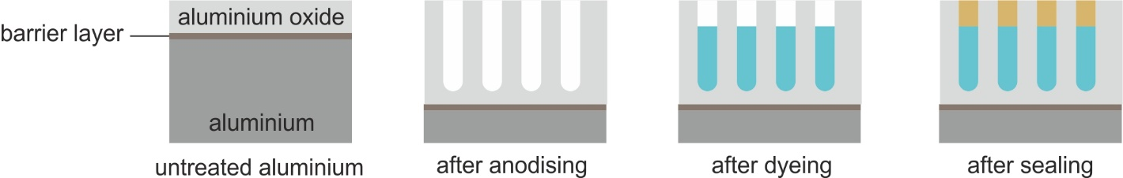

**Preliminary Test**

Take a small piece of aluminium metal sheet and hold it into the hottest area of the flame of the Bunsen burner until it glows. Observe how the metal behaves – why are there no drops of liquid aluminium (m.p. 660 °C)?

|  |  |  |  |  |  |  |  |  |  |  |  |  |  |  |  |  |  |  |  |  |  |  |  |  |  |  |  |  |  |  |  |  |  |
| --- | --- | --- | --- | --- | --- | --- | --- | --- | --- | --- | --- | --- | --- | --- | --- | --- | --- | --- | --- | --- | --- | --- | --- | --- | --- | --- | --- | --- | --- | --- | --- | --- | --- |
|  |  |  |  |  |  |  |  |  |  |  |  |  |  |  |  |  |  |  |  |  |  |  |  |  |  |  |  |  |  |  |  |  |  |
|  |  |  |  |  |  |  |  |  |  |  |  |  |  |  |  |  |  |  |  |  |  |  |  |  |  |  |  |  |  |  |  |  |  |
|  |  |  |  |  |  |  |  |  |  |  |  |  |  |  |  |  |  |  |  |  |  |  |  |  |  |  |  |  |  |  |  |  |  |
|  |  |  |  |  |  |  |  |  |  |  |  |  |  |  |  |  |  |  |  |  |  |  |  |  |  |  |  |  |  |  |  |  |  |
|  |  |  |  |  |  |  |  |  |  |  |  |  |  |  |  |  |  |  |  |  |  |  |  |  |  |  |  |  |  |  |  |  |  |
|  |  |  |  |  |  |  |  |  |  |  |  |  |  |  |  |  |  |  |  |  |  |  |  |  |  |  |  |  |  |  |  |  |  |
|  |  |  |  |  |  |  |  |  |  |  |  |  |  |  |  |  |  |  |  |  |  |  |  |  |  |  |  |  |  |  |  |  |  |

**Experimental**

**Lab**

**Cleaning of the casing of the ball pen**

1. Take the ball pen apart
2. Polish the casing using wet-sand paper
3. Insert the aluminium rod into the casing
4. Place the casing for 60 seconds into an a solution of 20 % NaOH
5. Rinse the casing for at least 60 seconds under flowing water
6. Place the casing for 10 seconds into an a solution of 30 % nitric acid
7. Rinse the casing for at least 60 seconds under flowing water, then rinse it with distilled water. During all of these steps avoid touching the casing with your fingers

**Anodising**

1. Place the aluminium metal sheet into the solution of 20 % sulphuric acid and connect it with the **negative** outlet of the power source (cathode)
2. Insert the aluminium rod holding the casing into the aluminium tube and connect it with the **positive** outlet of the power source (cathode)
3. Immerse the casing into the sulphuric acid and centre it horizontally and vertically relative to the cathode
4. Anodise the casing for 30 minutes at a current of 0.75 - 0.80 A; check from time to time that the current is still within these boundaries
5. Switch off the power, remove the casing from the electrolyte and rinse the casing for 5 minutes under flowing water; finally rinse it with distilled water

**Dyeing**

1. Immerse the casing briefly into the dye solution 4 to 5 times then rinse it with distilled water
2. Repeat this sequence with the same or a different colour – in this way colour gradients can be achieved; take care that the casing remains moist throughout the entire process
3. Once the colour is as desired rinse the casing thoroughly and place it for 5 minutes in the sealing bath

# Safety Hazards

|  |  |
| --- | --- |
|  | Sodium hydroxide, sulphuric acid and nitric acid are highly corrosive – wear eye protection and avoid any contact with your skin |

**Disposal**

Any washing water can be poured down the drain

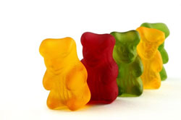**Gummy Bears (Vegan)**

**Lab**

**Theory**

Inverted sugar is made from sucrose via the addition of catalytic amounts of acid. The acid splits the di-saccharide into its monomers glucose and fructose. During this process a molecule of water is consumed which is why this step is also referred to as **hydrolysis**. Inverted sugar has a somewhat milder and fruitier taste than sucrose and also tends to crystallise more slowly.



**Ingredients**

|  |  |  |
| --- | --- | --- |
| * sucrose * Tartaric acid * Apple pectin | * Tri-sodium citrate dihydrate * citric acid solution 50% | * food colourant * aroma |

**Preparation of inverted sugar**

25 g sucrose (crystalline sugar) and half a spatula full of tartaric acid are mixed in a 100 mL beaker with 12.5 mL water and heated while stirring to 75 °C. After 30 minutes half a spatula of sodium hydrogen carbonate (Na(HCO3)2) is added in order to neutralise the mixture. The resulting viscous syrup briefly expands after the addition. The beaker is sealed with tin foil and stored until needed for the production of gummy bears.

**Preparation of the starch mould**

Prior to use the starch has to be dried for several hours at a temperature of 100 °C. Using a pair of tweezers commercial gummy bears are pressed into the starch bed to create the mould. Take care that the distance is chosen in such a way that the moulds do not collapse.

**Gummy bear production**

In a 200 mL beaker 15 mL of water (or fruit juice) are placed and heated to approximately 50°C. Mix together 0.15 g sodium citrate, 1.2 g apple pectin and 6 g sucrose in a 50 mL beaker and add the mixture to the warm water while stirring with a glass rod until the pectin is completely dissolved. Take care that there are no lumps in the mixture.

Weigh 5 g of sucrose into a 30 mL beaker and add the sugar together with the previously prepared inverted sugar to the pectin solution. While constantly stirring heat the mixture until it reaches it boiling point (approximately 100°C ought to be reached) then add any food colourant and aroma to the mixture.

**From this point onwards it is crucial to work very fast and efficiently: Add 1.75 mL of the citric acid solution, mix and pour the mixture immediately into the mould. If you wait for too long the mixture will solidify prematurely! It is not possible to re-liquefy the mixture once it solidified...**

After 20-60 minutes the gummy bears are sufficiently solid to remove them from the mould either using your fingers or a pair of tweezers. Cover them with a thin layer of starch to prevent them from sticking together.

**Disposal**

Orally